Task 1

What is a Zynq device?
A Zynq device is a "All programmable System on a Chip (AP SoC)". It combines the software programmability of a ARM-base Processor and the hardware programmability of an FPGA. For that it integrates an ARM-Processor with an FPGA. Most Zynq-Devices also have an CPU, DSP and an ASSP to offer a fully scalable SoC platform.

What is the difference between the PS and the PL?
The PS is the "Processing System", which integrades the Application Processor Unit (APU), mostly the ARM-Processor, the "Memory Interfaces", I/O Peripherals, like GPIOs, Ethernet, USB, CAN-Controller, UART-Controllers and I2C-Controllers. It is also for the software programming part of the AP SoC.
The "Programmable Logic" is the other part of the AP SoC. Most Zynq devices has an FPGA which is the PL. It also integrades some modules on it, like an AD-Converter or an Clock management. Its also for the hardware programmability part of the Zynq device.

What is the AXI standard?
The AXI standart is part of ARM AMBA, a family of micro controller buses. It defines a standard protocol for Intellectual Property (IP). It works with a "Master interface" and an "Slave interface" and defines the communication between these two partners.
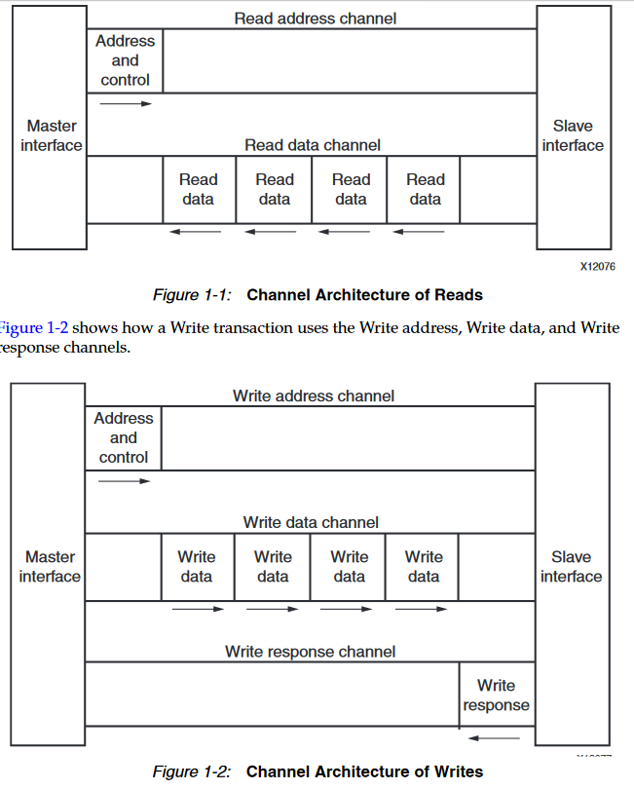

What is the difference between interconnect and interface?
An interface is like a port to connect the Hardware with the world outside, like serial ports, or ethernet (mostly called Ethernet Interface). On the other side, an interconnect is an build network between some internal modules of the hardware, or mostly, of the software. Like AXI uses an AXI Interconnect to connect AXI Masters and Slave together.
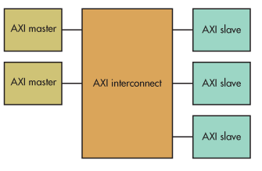

So an interface is basicly an door to the outside, while an interconnect is an association of modules on the hardware, or software.

What is a Microblaze?
A "Microblaze" is a microcontroller of Xillinx, which is not implemented in hardware! It's coded in VHDL or Verilog an is called an Softcore. It uses some special FPGA-Modules to reduce his size and runtime. This "softcore" is a fully capable 32-Bit-RISC processor, with cache, pipelining and some interrupts. Some of them also have an FPU or some shift registers.

